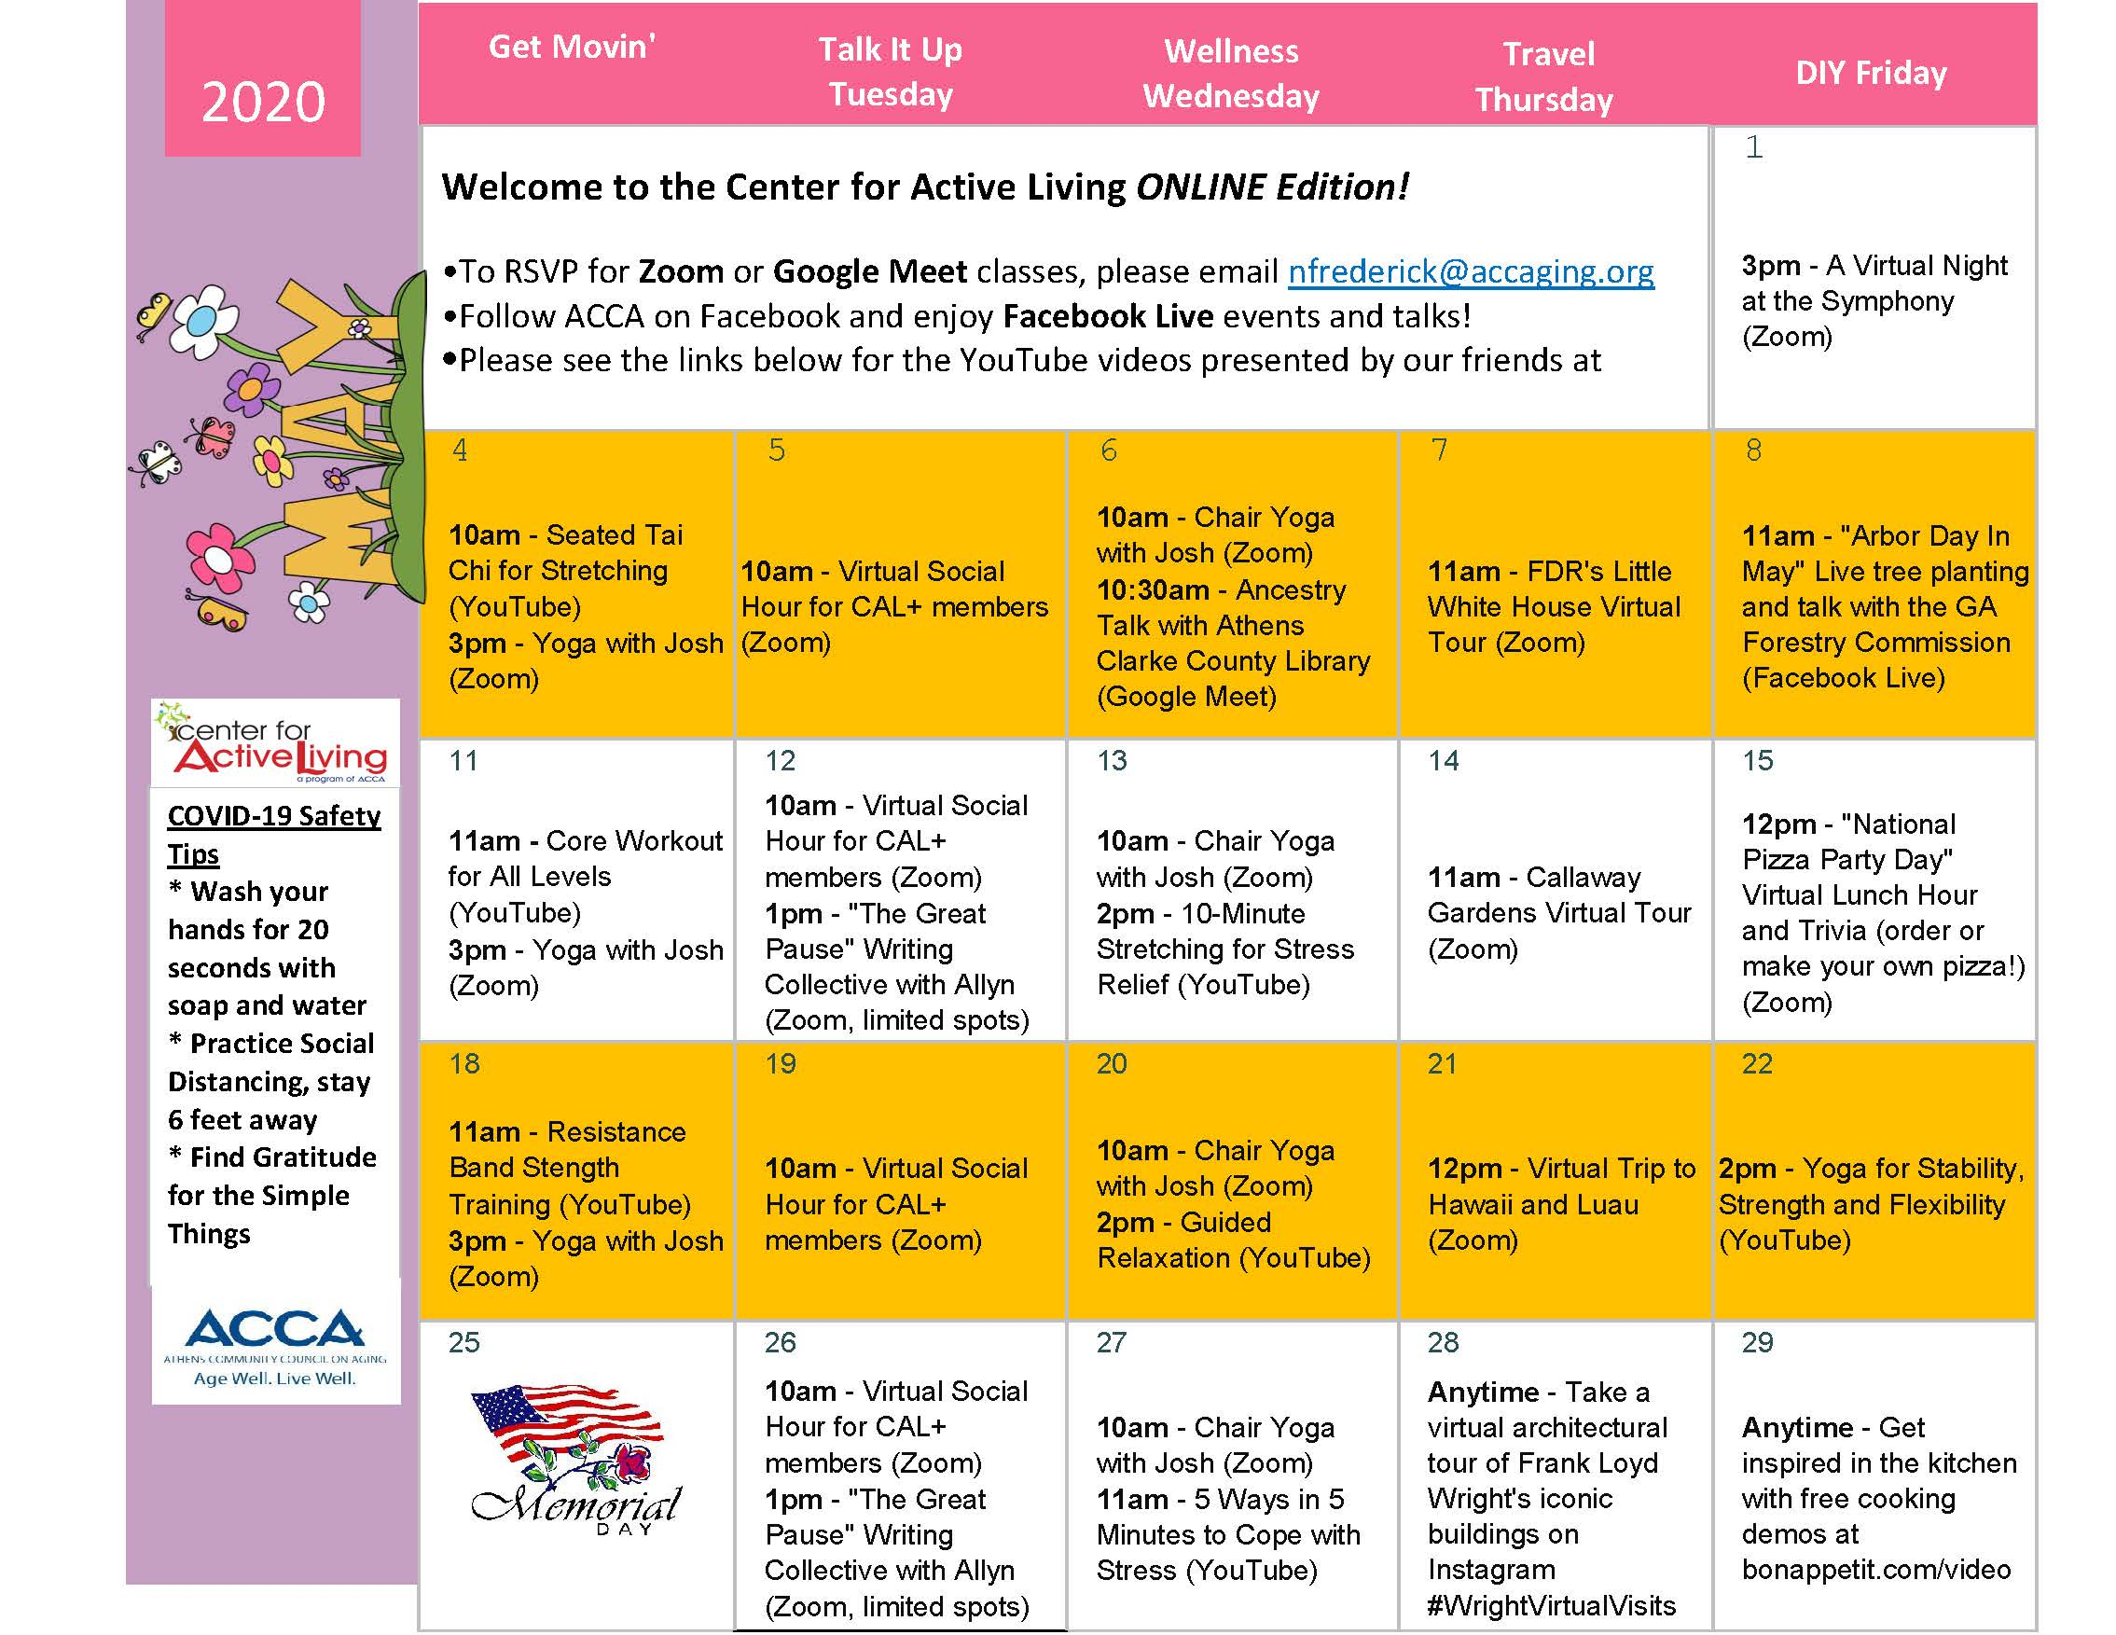
For continued updates, visit us at http://www.accaging.org
YouTube Video Links
YouTube videos presented by our friends at Piedmont Athens Regional Medical Center
May 11th Core Workout for All Levels
https://www.youtube.com/watch?v=gfJn8YyXW50&list=PLYjNFvCmGuTGp4yBDiHDCGSCRVhI8-ECp
May 13th 10-Minute Stretching for Stress Relief
https://www.youtube.com/watch?v=jnHL_NsaGPE&list=PLYjNFvCmGuTGp4yBDiHDCGSCRVhI8-ECp&index=2
May 18th Resistance Band Strength Training
https://www.youtube.com/watch?v=uTZgY02Acac&list=PLYjNFvCmGuTGp4yBDiHDCGSCRVhI8-ECp&index=3
May 20th Guided Relaxation
https://www.youtube.com/watch?v=F1tvTW44FBo&list=PLYjNFvCmGuTGp4yBDiHDCGSCRVhI8-ECp&index=4
May 22nd Yoga for Stability, Strength and Flexibility
https://www.youtube.com/watch?v=7exhxvPQ04Q&list=PLYjNFvCmGuTGp4yBDiHDCGSCRVhI8-ECp&index=5
May 27th 5 Ways in 5 Minutes to Cope with Stress
https://www.youtube.com/watch?v=_URMNdPp914&list=PLYjNFvCmGuTGp4yBDiHDCGSCRVhI8-ECp&index=6
Stay Safe. Stay Well.

